IT24100054

J P S Jayaweera

PS LAB 04

1). 



2),3).

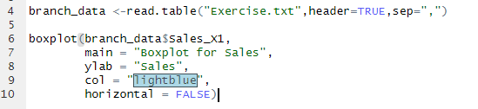

04),05).



